MAZDA MX-30 e-skyactiv R-EV

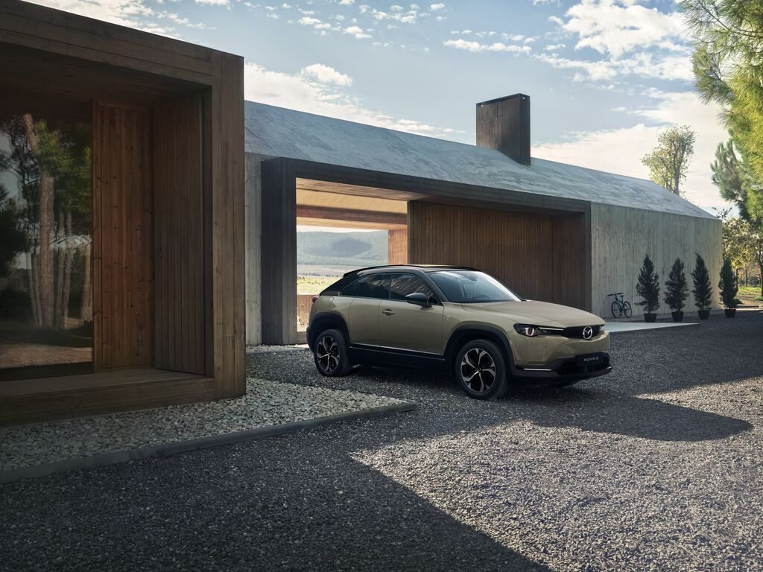
Contents
1| Message from the Program Manager 3
2| Mazda MX-30 e-Skyactiv R-EV 5
3| phev with rotary engine as a generator 13
4| MX-30 e-Skyactiv R-EV ‘Edition R’ 17
5| TECHNICAL SPECIFICATIONS 20

- Message from the Program Manager
Amidst the recent restrictions of the Covid-19 pandemic, we have all made adjustments to our lifestyles in response to changes in society. Now these adapted ways of living and working are becoming the new normal and we can access so much information without even leaving the house, it’s arguable that real-world experiences are becoming more and more valuable.
That’s why we hope Mazda customers can take part in the joy of seeing and touching things in person and engage with new experiences themselves. And why we want to accompany them as they seek a ‘life that’s true to themselves’, joining them in the smiles and laughter that lie beyond these challenges and new experiences. It was with this desire that we released the Mazda MX-30 in 2020, which I believe offers customers the following unique values:
- The ability to move around comfortably and easily, in a way that is gentle on the environment.
- The ability to move as you like without feeling restricted, confident in your own thinking.
- The ability to refresh yourself and feel more positive and at ease whenever you get in the car.
The MX-30 delivers these values through the adoption of electrification technologies, a pleasant Jinba Ittai driving experience, design with a familiar, approachable feel, and a cabin space that uses materials with a warmth that settles the mind and heart - making the time a customer spends with their car and the experiences it provides truly creativity-inspiring.
The MX-30 is the leading model of Mazda’s electrification strategy. In addition to the MX-30 BEV – our first mass-produced all-electric vehicle – we are now adding a plug-in hybrid model to the range - the MX-30 e-Skyactiv R-EV. With electrification technology intrinsic to every powertrain variation, the MX-30 truly embodies the Mazda multi-solution strategy toward carbon neutrality. It allows customers to choose an electrified model to best suit both their lifestyles and the characteristics of the country they live in.
With society in a transitional phase, moving towards more widespread use of electric vehicles, some people may be interested in electric vehicles as a way of contributing to environmental sustainability but may not feel ready to take the plunge and buy one due to concerns about limitations such as driving range or the charging environment.
We wanted to offer these customers a new option that solved these challenges – a car that could serve as an electric vehicle for everyday needs but could also use an engine to generate power for longer drives so drivers could relax and enjoy their trip.
We also wanted it to use entirely pure, comfortable electric motor-powered drive comparable to the BEV model the entire time the vehicle was running, even while generating power. That’s why we designed the MX-30 e-Skyactiv R-EV as a new plug-in hybrid model that combines the best aspects of all-electric vehicles and series hybrids to offer customers more ways of using their car as an electric vehicle.
For example, some people will be raising their children surrounded by nature in the suburbs and commuting into the city for work. Others may be the opposite – living in the city and heading out to explore the outdoors with family and friends at weekends. Then there are customers concerned about the future of our planet who want to contribute to a sustainable global environment through the way they live. We want the MX-30 e-Skyactiv R-EV to be a partner that will help all of these customers to create a new lifestyle in which they will be able to enjoy an active life while still contributing to a sustainable future.
Uniquely, the MX-30 e-Skyactiv R-EV uses a rotary engine to generate power, a symbol of Mazda’s ‘never-stop challenging’ spirit – our special love of a new challenge and determination to push through despite the odds. Approximately ten years since the discontinuation of mass-production rotary engine vehicles, the rotary engine is making a comeback in the age of electrification – as a generator. To commemorate the return of the rotary engine in this new way, we will be offering a Special Edition MX-30 e-Skyactiv R-EV with a design inspired by the rotary engine.
The MX-30 e-Skyactiv R-EV is compatible with both normal and fast charging, offers 1500 W power supply functionality, and is equipped with three drive modes drivers can choose from to suit different driving situations. And not only does it offer users more options while the car is running, but also at their destination, where it has the capacity to provide support in the event of a natural disaster or power outage.
It is my hope that the three MX-30 models will enable more Mazda customers to resonate with the idea of living life in a way that is true to themselves, and that these customers will be able to enjoy experiences that spark joy in their lives more freely and more frequently, wherever life takes them.
Mazda MX-30 Program Manager
Wakako Uefuji
- MAZDA MX-30 e-SKYACTIV R-EV
- A Mazda-unique plug-in hybrid that combines the best aspects of all-electric vehicles and series hybrids to offer customers more ways of using their car as an electric vehicle.
Driving range is a key consideration for customers thinking about purchasing an electric vehicle. Although some may be considering an electric vehicle from the perspective of environmental sustainability or because the way they use their car is changing, many others may not feel ready to take the plunge due to concerns about the driving range or charging environment.
The MX-30 e-Skyactiv R-EV is a new option that responds to the needs of customers like these, who want a car that they can use as an electric vehicle as much as possible for everyday needs but don’t want to be worrying about range limits or charging on longer trips.
Electric driving range varies greatly depending on the capacity of the vehicle’s on-board drive battery. However, changing to a high-capacity battery to extend the range comes with challenges. Larger batteries are more expensive, so using one would result in a more expensive vehicle. Additionally, a life cycle assessment (LCA) perspective demands optimising the battery capacity for the vehicle.
Plug-in hybrids are one realistic solution to electric vehicle range issues. Currently, the most popular plug-in hybrid system is a parallel hybrid system in which both an electric motor and engine are used to drive the vehicle. The MX-30 e-Skyactiv R-EV, however, uses a series hybrid system which is based on an all-electric system but adds a generator paired with a compact engine to eliminate concerns about driving range. The MX-30 e-Skyactiv R-EV was developed to be predominantly used as an electric vehicle and therefore offers customer value in the following three ways:
- In addition to an electric-only driving range of 85 km that allows customers to use it as an electric vehicle for everyday needs, it makes long trips stress-free due to the ability to generate power using a rotary engine.
- Customers enjoy a pure and comfortable driving experience comparable to that of the MX-30 BEV the whole time the car is running, due to the use of a series drive system in which the vehicle is always driven by the electric motor.
- Is equipped with charging and power supply functionality that can be used in the same way as that of an all-electric vehicle.
The Mazda MX-30 e-Skyactiv R-EV’s rotary engine is key to achieving this customer value. Rotary engines are known for being more compact than reciprocating engines with the same output. By using our rotary engine as a generator, we have been able to incorporate the best aspects of a series drive system, in which drive is entirely electric motor-powered, into a unique plug-in hybrid that offers customers more ways of using their car as an electric vehicle.
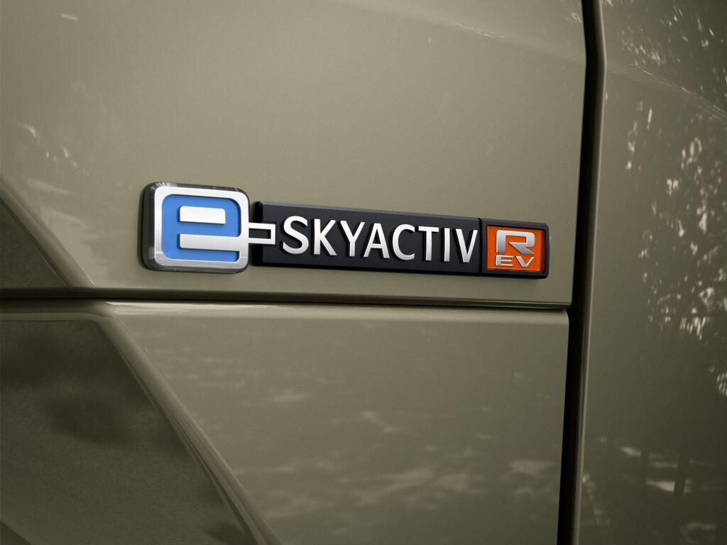
A car that can be used as an electric vehicle for everyday needs but can also use a rotary engine to generate power, making long-distance trips possible
Most conventional plug-in hybrids tend to have a lower electric-only driving range as they use an internal combustion engine as their main power source and include electric drive in conjunction with this. For the MX-30 e-Skyactiv R-EV, though, we carried out a customer survey about real-life BEV and PHEV usage and, based on the results of this survey, targeted 85 km of electric-only drive on a full battery charge so that customers can predominantly use their car as an electric vehicle.
However, the MX-30 e-Skyactiv R-EV can also handle longer drives, with the rotary engine generating energy to power the drive battery when customers need to drive further than 85 km - a weekend trip, for example.
One of the key characteristics of rotary engines makes this possible – they’re compact and don’t take up much space. Although our newly-developed rotary engine generator uses an 830 cm³ engine with a maximum output of 55 kW (75 PS) at 4,500 rpm, it is more compact than a reciprocating engine with similar output.
This is what made coaxial placement and integration of the MX-30 e-Skyactiv R-EV rotary engine with a thin, high output generator and a 125 kW (170 PS) high output motor possible. It enabled us to achieve a compact set-up that fitted in the engine bay easily and didn’t require any compromise in cabin space.
We then combined this compact drive unit with a 17.8 kWh lithium-ion battery and a 50 litre petrol tank. As a result, the MX-30 e-Skyactiv R-EV not only offers an 85 km electric-only driving range for everyday needs, but also, due to an ability to generate power using the rotary engine, longer drives without range anxiety, and the same 140 km/h maximum speed as the MX-30 BEV.

A pure and comfortable driving experience made possible by motor-powered drive
Successfully contributing to the environment through your car while simultaneously enjoying an active lifestyle isn’t all about ensuring a stress-free driving range – driving performance is another crucial aspect of this. As the rotary engine is only used to generate power and not to drive the vehicle, the MX-30 e-Skyactiv R-EV offers the same, high quality, motor-powered Jinba Ittai driving experience as the MX-30 BEV model the entire time the vehicle is running.
When charged daily, the MX-30 e-Skyactiv R-EV can be used as an electric vehicle for everyday needs as well as making it possible for customers to enjoy a pure, comfortable driving experience comparable to the MX-30 BEV, even while generating power using the rotary engine. In addition, drivers can choose between three simple, stress-free drive modes that not only suit their diverse driving needs, but also offer environmental benefits.

A series plug-in hybrid that offers a good balance of drive, convenience, and environmental performance
For some of our customers, life entails raising their children surrounded by nature in the suburbs and commuting into the city for work. For others it may be the opposite – living in the city and heading out to explore the outdoors with family and friends on weekends. Either way, such lifestyles will probably involve considerable time spent on motorways. The MX-30 e-Skyactiv R-EV continues to use entirely motor-powered drive in these kinds of situations, such as driving at high speeds on motorways or climbing hills, even while generating power using the rotary engine.
The MX-30 e-Skyactiv R-EV offers the added benefit of using a rotary engine to generate and supply the battery with power in situations such as when sudden acceleration demands higher output, when customers wish to conserve the battery so they can power electrical devices or appliances at their destination, or when they need to drive long distances. In this way, the MX-30 e-Skyactiv R-EV delivers an optimal balance of sustainability, driving performance, and enhanced convenience as an electric vehicle, making it easy and stress-free for drivers to use their car in an environmentally friendly way.
Easier to use with three drive modes to choose from
The MX-30 e-Skyactiv R-EV is equipped with three drive modes that drivers can choose from based on the driving situation and the way they want to use their car: Normal mode, EV mode, and Charge mode. Choice of drive mode does not affect the 140 km/h maximum vehicle speed.
Normal mode delivers electric drive with good running performance. As long as there’s enough battery charge, the car will use electric drive in Normal mode, with the rotary engine inactive. If more power is required than the battery level can deliver – for example, when accelerating – the rotary engine generator will activate based on the degree of accelerator opening and supply the battery with more power. Thus, the MX-30 e-Skyactiv R-EV delivers outstanding acceleration performance and ensures drivers can always enjoy great driving.
Drivers can turn EV mode on when they want to stay in electric drive for as long as possible. This mode will ensure the vehicle uses electric drive exclusively until the gauges show the battery is completely drained. However, if the driver suddenly depresses the accelerator pedal beyond a certain point (equivalent to the kickdown switch function on a standard automatic transmission vehicle), the rotary engine will activate and generate additional power to enable rapid acceleration.
Charge mode can be used to safeguard the necessary amount of battery for situations such as keeping the car in EV mode to drive quietly through a residential area at night, or using the car battery to power devices, such as while away camping. Users have the option of setting the amount of battery charge they want to reserve in increments of 10%.
The generator will activate when battery charge drops below the specified reserve level, charge the battery to the set level, and maintain that level of charge. Once battery charge is above the set level, the car will operate in the equivalent to Normal mode until the battery depletes to the specified level. It will then use the rotary engine generator to keep the battery at that level.

The same Jinba Ittai drive as the MX-30 BEV
When we launched the MX-30 BEV in 2020, we wanted it to be a car that enabled drivers to relax and made driving more enjoyable with every outing – so much so that customers would look forward to the time they spend behind the wheel each day. That’s why we focused on refining the MX-30 to deliver a driving experience that was comfortable and offered pure enjoyment.
The MX-30 e-Skyactiv R-EV uses the same drive control technology we developed for the original MX-30 BEV. This means the new model also achieves a comfortable, road-hugging drive, seamless vehicle movement, and excellent controllability that offers intuitive handling as if the car were an extension of the driver’s body.
To achieve this, the MX-30 e-Skyactiv R-EV shares the following technologies with the MX-30 BEV:
- Electronic G-Vectoring Control Plus (e-GVC Plus) technology that delivers seamless vehicle movement in all directions, achieving handling that feels even more natural to occupants.
- An accelerator pedal designed with human characteristics in mind that achieves high precision torque control.
- A regenerative-friction brake system that detects the amount drivers depress the brake pedal and uses this to determine how much braking force is required, regenerates as much energy as possible within this braking force range and compensates for any shortfall with friction braking force. As a result, the system offers high efficiency energy regeneration while still delivering braking force in line with the driver’s intentions.
- Steering wheel paddles that offer drivers the ability to control the vehicle speed at will across a wide range of driving scenarios, and easily control front-rear load.

Enhanced charging functionality
The MX-30 e-Skyactiv R-EV is compatible with single-phase and three-phase normal (AC) charging as well as fast (DC) charging methods. Moreover, it can be connected to Type 2 and CCS charging systems, maximising its capacity to recharge at the greatest number of available locations.
Using a 36 kW+ fast charging unit, the battery can be charged from 20% SoC to 80% in approximately 25 minutes. With three-phase 11 kW normal (AC) charging, the battery can be refilled in approximately 50 minutes. One-phase 7.2 kW normal (AC) charging will take approximately 1 hour and 30 minutes.
Based on research into the charging environment of each market, the charging port has been positioned on the rear fender. This position also allows customers to maintain natural posture while connecting the charging cable. The MX-30 e-Skyactiv R-EV is equipped with a charging indicator so owners can easily check the charge status. And, reducing user concerns of electric shock or system damage while charging, the charging port is fitted with a cap to prevent the ingress of rain or dust.

Model | Battery capacity | Charging method | (Maximum acceptable input) |  | Charging unit output |  | Charging time
MX-30 e-Skyactiv R-EV | 17.8 kWh | Normal (AC) | Single-phase | 7.2 kW | Single-phase | 7.2 kW or above | Approx.  1 hr. 30 min
MX-30 e-Skyactiv R-EV | 17.8 kWh | Normal (AC) | 3-phase  (European models only) | 11 kW | 3-phase | 11 kW or above | Approx.  50 min
MX-30 e-Skyactiv R-EV | 17.8 kWh | Fast (DC) | 36 kW |  | 36 kW or above |  | Approx.  25 min

Power on the go: Personal power supply
The MX-30 e-SKYACTIV R-EV supports V2L (vehicle to load) power supply functionality. V2L enables owners to run electrical appliances and devices of up to 1500 W using the power outlet in the cargo space. This convenient feature allows owners to take cooking appliances with them when camping, or to use their notebook outside for a change of scenery without worrying about its battery level.

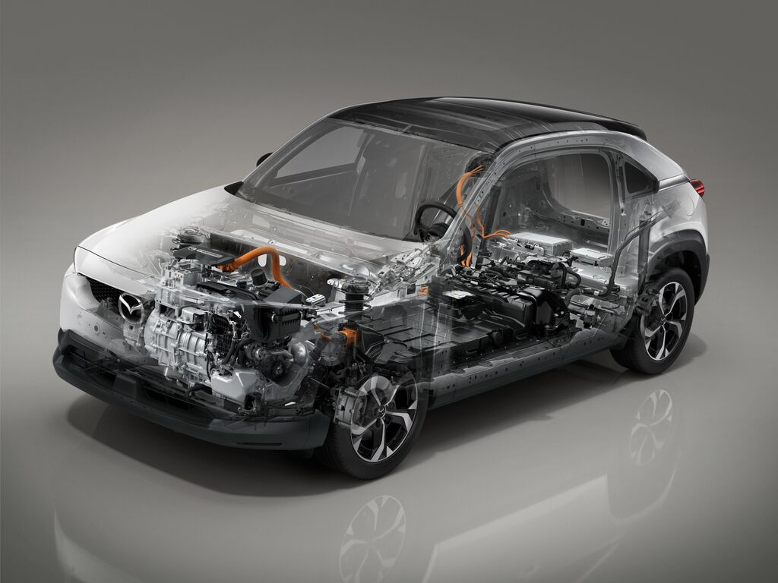

- PHEV WITH ROTARY ENGINE AS A GENERATOR
- Making a strategic and genuine contribution to environmental sustainability through multiple electrification technologies
At Mazda, we want to contribute to a genuine reduction in carbon dioxide emissions through our Multi-Solution Strategy. This looks at sustainability from a life cycle assessment (LCA) perspective, considering carbon dioxide emissions throughout the entire vehicle life cycle from production to disposal.
This strategy also factors in regional variables such as differences in car use between markets and the suitability of electricity generation configurations and power sources therein, ultimately aiming to offer vehicles with power sources that will result in the lowest carbon dioxide emissions for that market.
One of the ways we are doing this is through the introduction of multiple electrification technologies that use a rotary engine to generate power. Rotary engines are smaller than reciprocating engines with similar output making them space-saving and easy to fit into the drivetrain layout. This means they can be easily combined with other components such as generators, batteries and fuel tanks to create multiple powertrain options for the same vehicle, such as plug-in hybrids and series hybrids. As a result, we will be able to offer different products that take the regional characteristics of each market into consideration.

The advantages of a plug-in hybrid system
The basic configuration of the MX-30 e-Skyactiv R-EV plug-in hybrid system commercialises one of our multiple electrification technologies that use a rotary engine as a generator, offering customers numerous advantages.
The rotary engine generator
Launched on May 30, 1967, the Mazda Cosmo Sport (Mazda 110S) was the first car in the world to be powered by a two-rotor rotary engine. A compact, lightweight and extremely quiet unit that delivered high output, the rotary engine was referred to as the ‘dream engine’ within the automotive industry. Mazda succeeded in commercialising this technology for 45 years and mass-produced close to 2 million rotary engine powered cars, more than any other car manufacturer.
Ever since, the rotary engine has remained a symbol of Mazda’s ‘never-stop challenging’ spirit – our love of a new challenge and determination to push through despite the odds. With the discontinuation of the RX-8, Mazda ended mass-production of the rotary engine in June 2012. Today, some 10 years later, the rotary engine is making a comeback. This new rotary engine has been adapted to meet the needs of our times and is now being used to generate power rather than as a drive unit.

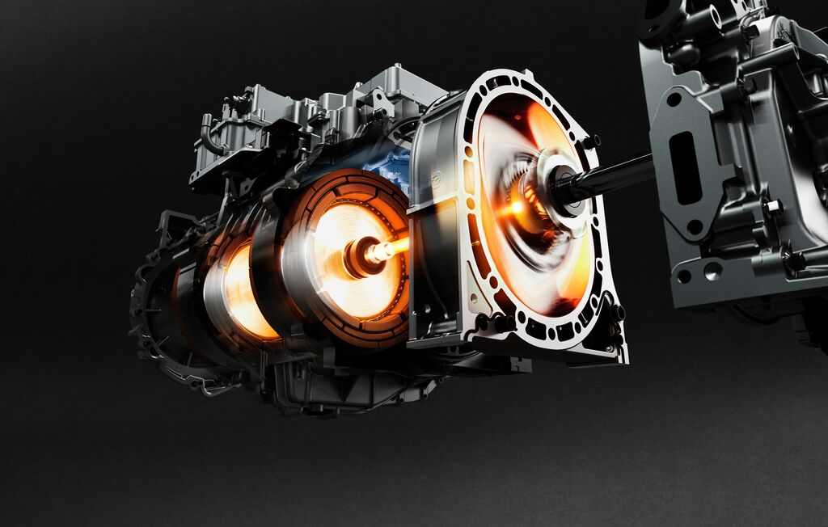

More compact
While the 13B Renesis engine used on the RX-8 was a 654 cm³ two-rotor engine, the MX-30 e-Skyactiv R-EV uses an 830 cm³ single rotor format for the rotary engine generator. With a 120 mm generating radius (R) and 76 mm rotor width, its compact size enables coaxial placement and integration with the electric motor, decelerator and generator to achieve a unit with an overall width of less than 840 mm that fits on the same body frame as the MX-30 BEV.
We also successfully reduced the weight of the engine by over 15 kg by using aluminium for the side housing section of the engine structure instead of the iron used on the Renesis engine.
Better fuel economy and lower emissions
The main contributor to increasing fuel economy and reducing emissions on the MX-30 e-Skyactiv R-EV rotary engine was the use of direct fuel injection. When fuel is injected into the ports on a conventional rotary engine, a lot of the air-fuel mixture ends up at the back of the combustion chamber, not fully combusting and eventually being expelled as unburned gas. This has a negative effect on both fuel economy and engine output.
The rotary engine on the MX-30 e-Skyactiv R-EV uses direct fuel injection, making it possible to distribute the air-fuel mixture to the main combustion area and achieve more efficient combustion. Additionally, direct fuel injection atomises the fuel at the time of injection making it possible to sufficiently vaporise fuel even at lower temperatures. This also helps prevent the injection of excess fuel.
The engine also adopts an exhaust gas recirculation (EGR) system to improve fuel efficiency. Adding an EGR system that operates mostly at low rpm and low loads improves fuel economy by preventing cooling loss caused by rotary engine combustion chambers having a greater surface area than those of a reciprocating engine.
Evolution of the gas seals and sliding surface (inner housing surface)
Apex seals are attached to the tip of each rotor to ensure the combustion chambers are airtight. For the MX-30 e-Skyactiv R-EV, we increased the width of these seals to 2.5 mm to improve wear resistance. We also changed the plating on the trochoid surface inside the housing to reduce wear and frictional resistance.
For the sides of the housing, we use aluminium for the surface of the side housing and have added high velocity oxygen fuel coating to add a ceramic coating which also reduces wear and frictional resistance.
The battery
When considering the battery for the MX-30 e-Skyactiv R-EV, we wanted to secure enough capacity for 85 km of electric-only driving, while also meeting the needs of customers wanting to use their car for long trips without worrying about charging. In addition, we were committed to considering the environmental impact of the battery over the course of the entire vehicle life cycle. A 17.8 kWh battery was chosen to fulfil these requirements.
Like the MX-30 BEV, the MX-30 e-Skyactiv R-EV uses lithium-ion battery cells. To make the battery as compact as possible, we chose a high energy density set-up and wired the high voltage components using busbar wiring. The thin structure of the refrigerant cooling system also keeps the height of the battery housing to a minimum. We also enhanced body rigidity by connecting the battery housing firmly to the vehicle body and introduced a 50 litre fuel tank with minimal impact on cabin space.
The electric motor
The MX-30 e-Skyactiv R-EV is equipped with a high output motor with a maximum output of 125 kW (170 PS) at 9,000 rpm that can produce up to 260 Nm of torque at 4,481 rpm. The motor body is oil cooled, which contributes to a more compact drive unit.
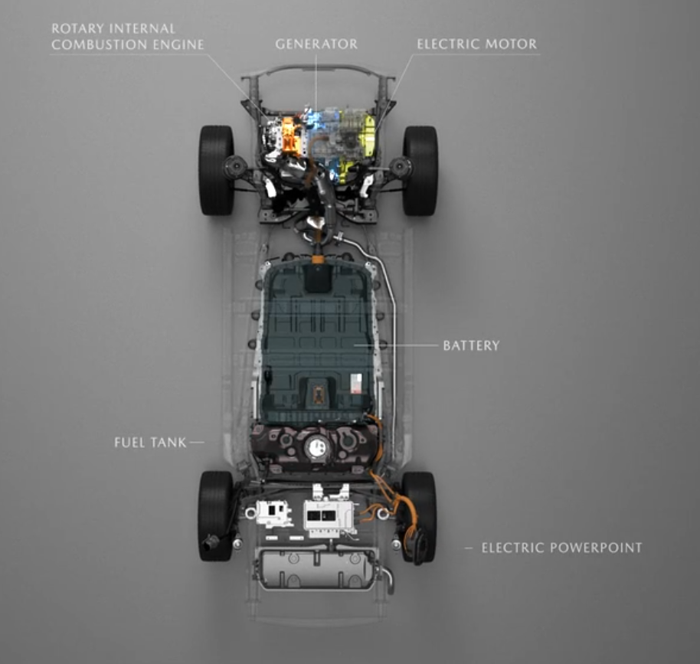
- MX-30 E-SKYACTIV R-EV ‘EDITION R’
- Exclusive design features and Special Edition R that commemorates the return of the rotary engine.
The MX-30 e-SKYACTIV R-EV has two exclusive features that are not included on other models in the MX-30 line-up.
The first is model-specific MX-30 e-Skyactiv R-EV badging. The MX-30 e-Skyactiv R-EV exterior will feature two unique emblems. The first is an e-Skyactiv R-EV emblem on the right side of the vehicle rear. The second is an emblem in the shape of a rotor above the front fenders. The centre of the design features the letter “e” as a motif that represents energy generation, and we chose an orange accent to convey the power required to generate energy.
Another exclusive feature is the wheel design. The aluminium wheels on the MX-30 e-Skyactiv R-EV will feature a design with improved aerodynamic performance. Although the previous MX-30 aluminium wheel design also prioritized aerodynamics, we updated the shape of the rim cross-section on the new design to the optimum shape, achieving wheels that are both lightweight and have significantly less air resistance. We also chose a black base tone for the wheels to give them a sharp look.
Edition R
Mazda was the first company in the world to successfully mass-produce the rotary engine. The rotary engine is a special part of Mazda history and represents our ‘never-stop challenging’ spirit – our special love of a new challenge and determination to push through despite the odds. And despite discontinuing mass-production rotary engine vehicles in 2012, we have continued research and development of the rotary engine, determined to never let its light go out.
Ten years later, the MX-30, the leading model for Mazda electrification technology, gives the rotary engine a new role, bringing it back as a generator. Edition R is a special edition vehicle that commemorates the return of the rotary engine in this way (the R stands for ‘return’). It features a bespoke design infused with elements that remind customers who purchase one that they own a vehicle equipped with a rotary engine.

Exclusive exterior body colour: Maroon Rouge Metallic
We chose Maroon Rouge Metallic as the exclusive body colour for the Edition R exterior. Maroon Rouge Metallic pays homage to the roof colour of the Mazda R360 Coupe, our first passenger vehicle, and was also used on the 100th Anniversary special edition vehicles released in 2020. Now, we’re bringing the same colour back with a new look as the exclusive exterior colour for our special Edition R to commemorate the inclusion of the rotary engine on the new MX-30 R-EV. The Edition R trim features Maroon Rouge Metallic on the accent around the sides of the roof and black for the base body colour, roof, and interior trim to create a unique, streamlined look.

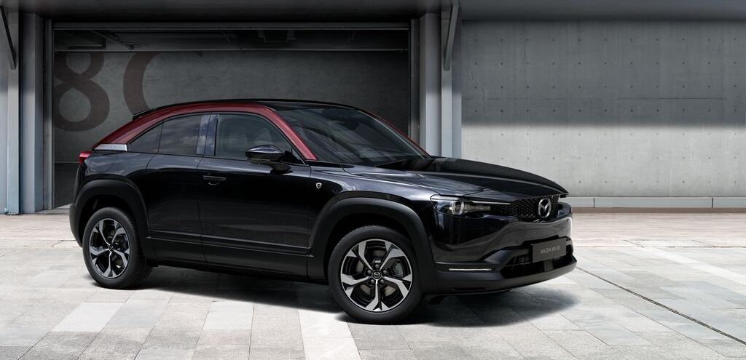

Key fob
For the Edition R key shell (the panels on the front and back of the key fob), we designed the horizontal edges of the front panel to curve at the same angle as the sides of the rotors in the MX-30 e-Skyactiv R-EV rotary engine. In addition, the sculpted sides of the key fob that slope outward are 2.5 mm wide - the same width as the rotor apex seal grooves – and are finished in a gloss coating. The Edition R exclusive logo is embossed on the front of the key shell. Customers won’t be able to see the rotary engine in actual vehicles, but by recreating elements such as the curved lines and dimensions of rotary parts in the key fob, we hope this will be a tangible reminder of their car’s unique powerplant.
Floor mats
The front and rear seat floor mats are embossed with an exclusive Edition R tag. Like the key fob design, the single white line on these orange floor mat tags is also the same width as the rotor apex seal grooves – approximately 2.5 mm. We used orange for both the colour of the tag itself and the colour of the stitching that runs along the floor mats either side of the tag. The colour orange was chosen to represent the energy the rotary engine generates. The driver and front passenger seat’s floor mats also include a chrome-plated badge featuring the MX-30 e-Skyactiv R-EV logo.
Headrests
The driver and front passenger seat headrests are embossed with an image of the MX-30 e-Skyactiv R-EV exclusive emblem and the R Edition logo. The exclusive embossed design on these headrests subtly communicates the fact that the vehicle is equipped with a rotary engine.
- TECHNICAL SPECIFICATIONS
Dimensions
Body type |  | SUV
Doors |  | 4 / 5
Seating capacity |  | 5 persons
External
Overall length (without licence plate holder) | mm | 4,395
Overall width | mm | 1,795
Overall width (mirror to mirror) | mm | 2,035
Overall height (without shark fin antenna; with driver 75 kg) | mm | 1,555
Wheelbase | mm | 2,655
Overhang front (without licence plate holder) | mm | 895
Overhang rear | mm | 840
Tread front | mm | 1,565
Tread rear | mm | 1,565
Ground clearance between axles (laden, with driver 75 kg) | mm | 130
Interior
Front headroom (with / without sunroof) | mm | 977.4 / 981.5
Rear headroom | mm | 939.2
Front shoulder room | mm | 1,412.1
Rear shoulder room | mm | 1,338
Front hip room | mm | 1,389.9
Rear hip room | mm | 1,232.9
Front legroom | mm | 1,057.5
Rear legroom | mm | 764.4
Boot
Volume (VDA) rear seats up (with under floor storage) | l | 350 / 332 with Bose
Volume (VDA) seats down up to ceiling (with under floor storage) | l | 1,155 / 1,137 with Bose
Height, from floor to tonneau cover | mm | 501
Load floor length to 2nd row | mm | 804
Load floor length to 1st row | mm | 1,518
Width between rear tire house | mm | 1,004
Liftgate opening width | mm | 996
Fuel tank
Fuel tank capacity | l | 50

e-Skyactiv Motor Details
Powertrain |  | FWD
Electric engine type |  | AC synchronous motor
Electric engine cooling system |  | Water-cooled
Max. power | kW (PS) | 125 (170) / 9,000
Max. torque | Nm | 260 / 0–4,481
Battery type |  | Lithium-ion
Battery cell |  | Prismatic
Battery capacity | kWh | 17.8
Battery capacity | V | 355
Battery weight | kg | 188.2
DC charging |  | Maximum input 36 kW
AC charging |  | Maximum input 11 kW three-phase, 7.2 kW single-phase

Rotary engine key specifications
Use |  | Power generation
Displacement | cm³ | 830 x 2
Trochoid dimensions  e: Eccentricity, R: the trochoid curve of the rotor movement (including the amount of parallel translation), b: width of the rotary housing | mm | e: 17.5, R: 120, b: 76
Compression ratio |  | 11.9:1
Maximum output | kW (PS) / rpm | 55 (75) / 4,500
Maximum torque | Nm / rpm | 117 / 4,000
Fuel supply mechanism |  | Direct injection (DI)
Intake port type |  | Side
Total intake ports |  | 2
Exhaust port setup |  | Side
Total exhaust ports |  | 2
Apex seals |  | 2.5 mm wide, 2-split cast iron
Suspension, Wheels, Steering, Brakes, Weight and Payload
Suspension
Front suspension |  | MacPherson strut
Rear suspension |  | Torsion-beam
Wheel & Tyres
Wheel size |  | 18 x 7 J
Tyre size |  | 215/55 R 18
Steering
Steering type |  | Rack and pinion
Power assist type |  | EPAS
Brakes
Type front |  | Ventilated Discs
Type rear |  | Solid Discs
Control |  | Regenerative cooperating brakes
Park brake |  | Electric Park Brake (EPB)
Weight and Payload
Minimum kerb weight | kg | 1,778
Gross vehicle weight (GVW) | kg | 2,251
Max. permissible front axle weight | kg | 1,254
Max. permissible rear axle weight | kg | 1,072
Max. roof load capacity | kg | 50

Performance Figures Mazda MX-30 e-Skyactiv R-EV (125 kW / 170 PS)
Performance
Top speed (with limiter) | km/h | 140
Acceleration (0-100 km/h) | s | 9.1
WLTP fuel consumption
EV driving range – combined | km | 85
EV driving range – city | km | 110
Fuel consumption weighted | l/100 km | 1.0
Energy consumption weighted | kWh/100 km | 17.5
WLTP emission1
Combined CO₂ emission | g/km | 21
European emission standards level |  | Stage 6 G2

mazda media contacts in europe
Countries | Contacts | Telephone
Europe  Mazda Motor Europe GmbH  www.mazda-press.com | John Rivett  jrivett@mazdaeur.com | +49 160 3354 786
Austria  Mazda Austria GmbH  www.mazda-press.at | Martin Seger-Omann  segeromann@mazda.at | +43 463 3888 226
Albania  Mazda Selected Markets Group | Ivana Mudrovčić  mudrovcic@mazda.hr | +385 1 6060 264
Belgium  Mazda Motor Belux  www.mazda-press.be | Peter Gemoets  gemoetsp@mazdaeur.com | +32 3 860 66 05
Bosnia & Herzegovina  Mazda Selected Markets Group | Ivana Mudrovčić  mudrovcic@mazda.hr | +385 1 6060 264
Bulgaria  Mazda Selected Markets Group | Ivana Mudrovčić  mudrovcic@mazda.hr | +385 1 6060 264
Croatia  Mazda Selected Markets Group | Ivana Mudrovčić  mudrovcic@mazda.hr | +385 1 6060 264
Cyprus  Mazda Selected Markets Group | Markéta Kuklová  mkuklova@mazdaeur.com | +420 739 681 120
Czech Republic  Mazda Selected Markets Group | Markéta Kuklová  mkuklova@mazdaeur.com | +420 739 681 120
Denmark  Mazda Motor Danmark  www.mazda-press.dk | Jannik Olsen  jolsen@mazdaeur.com | +45 43 25 21 06
Estonia  Inchcape Motors Finland Oy | Kamile Dumciute  kamile.dumciute@inchcape.fi | +370 693 92 533
Finland  Inchcape Motors Finland Oy | Lauri Rinnetmäki  lauri.rinnetmaki@inchcape.fi | +358 50 576 5085
France  Mazda Automobiles France S.A.S.  www.mazda-presse.fr | David Barrière  david.barriere@mazda.fr | +33 1 61 01 65 95
Germany  Mazda Motors (Deutschland) GmbH  www.mazda-presse.de | Jochen Münzinger  jmuenzinger@mazda.de | +49 2173 943 220
Greece  Mazda Selected Markets Group | Maria Katsarea  mkatsarea@autoone.gr | +30 213 0140 430
Hungary  Mazda Selected Markets Group  www.mazda-press.hu | Eszter Burovinc  burovinc@mazda.hu | +36 1 464 5007
Republic of Ireland  Mazda Selected Markets Group | David Bannon  dbannon@mazdaeur.com | +353 86 348 8635
Italy  Mazda Motor Italia S.r.L  www.mazda-press.it | Erika Giandomenico  egiandomenico@mazdaeur.com | +39 06 60 297 800
Latvia  Inchcape Motors Finland Oy | Kamile Dumciute  kamile.dumciute@inchcape.fi | +370 693 92 533
Lithuania  Inchcape Motors Finland Oy | Kamile Dumciute  kamile.dumciute@inchcape.fi | +370 693 92 533
Luxemburg  Mazda Motor Belux  www.mazda-press.lu | Peter Gemoets  gemoetsp@mazdaeur.com | +32 3 860 66 05
North Macedonia  Mazda Selected Markets Group | Ivana Mudrovčić  mudrovcic@mazda.hr | +385 1 6060 264
Malta  Mazda Selected Markets Group | Markéta Kuklová  mkuklova@mazdaeur.com | +420 739 681 120
Moldavia  Mazda Selected Markets Group | Ivana Mudrovčić  mudrovcic@mazda.hr | +385 1 6060 264
Montenegro  Mazda Selected Markets Group | Ivana Mudrovčić  mudrovcic@mazda.hr | +385 1 6060 264
Netherlands  Mazda Motor Nederland  www.mazda-press.nl | Marieke Mantje  mmantje@mazdaeur.com | +31 182 685 080
Norway  Mazda Motor Norge  www.mazda-press.no | Wenche Skarpodde  wskarpodde@mazdaeur.com | +47 66 81 87 70
Poland  Mazda Motor Poland  www.mazda-press.pl | Szymon Soltysik  ssoltysik@mazdaeur.com | +48 223 181 980
Portugal  Mazda Selected Markets Group  www.mazda-press.pt | Luis Morais  lmorais@mazdaeur.com | +351 21 351 2771
Romania  Mazda Selected Markets Group | Daniel Amzar  daniel.amzar@freecomm.ro | +40 21 20 74 740
Serbia  Mazda Selected Markets Group | Ivana Mudrovčić  mudrovcic@mazda.hr | +385 1 6060 264
Slovakia  Mazda Selected Markets Group | Markéta Kuklová  mkuklova@mazdaeur.com | +420 739 681 120
Slovenia  Mazda Selected Markets Group | Dimitrij Vušnik  dimitrij.vusnik@mazda.si | +386 1 420 40 89
Spain  Mazda Automóviles España S.A.  www.mazda-press.es | Natalia García  ngarcia@mazdaeur.com | +34 91 418 5468
Sweden  Mazda Motor Sverige  www.mazda-press.se | Johan Lagerström  jlagerstrom@mazdaeur.com | +46 300 31 810
Switzerland  Mazda (Suisse) SA  www.mazda-press.ch | Marine Deloffre  mdeloffre@mazda.ch | +41 22 719 3360
Ukraine  AUTO International | Julia Sivak  sivak@auto-intl.kiev.ua | +380 442 30 15 04
United Kingdom  Mazda Motors UK Ltd.  www.mazda-press.co.uk | Graeme Fudge  gfudge@mazdaeur.com | +44 1 322 622 691

#MX30
#Mazda
#CraftedInJapan

For more information, please visit the Mazda Press Portal
www.mazda-press.com

Electric-only driving range: 110 km for European WLTC urban range and 85 km for European WLTC combined range. Range values are for when EV mode is selected. These values are based on specific test conditions and actual electric-only driving range will vary depending on actual driving conditions. Additionally, in situations such as if the driver needs to accelerate suddenly and purposefully depresses the accelerator pedal significantly beyond a certain point (equivalent to the kickdown switch function on a standard automatic transmission vehicle), the rotary engine generator will activate and generate the energy for the required output.
In situations such as when the driver needs to accelerate suddenly and purposefully depresses the accelerator pedal significantly beyond a certain point (equivalent to the kickdown switch function on a standard automatic transmission vehicle).
Output will decrease if the battery level gets too low. If the battery runs flat, the rotary engine will automatically activate and generate power to assist acceleration performance.
As normal (AC) charging unit voltage and current differ between countries, the examples included here are based on typical single-phase 7.2 kW and three-phase 11 kW charging units. Charging time will also vary depending on the type of charging cable customers use.
Charging time when charging from SoC (state of charge) 20% to 80% using a charging unit that can deliver the maximum voltage accepted by the vehicle. (With ambient and battery temperatures of 25°C.) Actual charging times depending on conditions such as the charging unit voltage, the amount of battery remaining, and outside air temperature.
The chamber volume of 830 cm³ needs to be doubled according to Regulation (EU) 2017/1151.
Vehicles are homologated in accordance with the type approval procedure WLTP (Regulation (EU) 1151/2017; Regulation (EC) No 715/2007).

