2024 MAZDA CX-30

|  |
| --- |
|  |

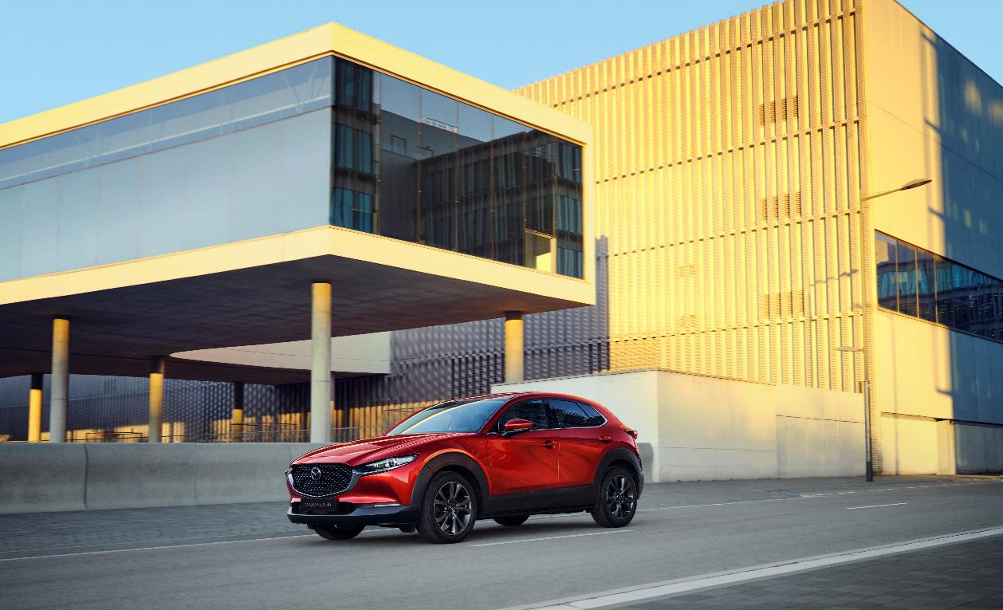

Contents

1| INTRODUCtion 3

2| Compact Exterior - Spacious, Versatile Interior 9

3| *Jinba Ittai*: Effortless, Engaging Driving 15

4| Skyactiv-Vehicle Dynamics: New-generation Control Technologies 20

5| Skyactiv-Vehicle Architecture: New-generation Structural Technologies 22

6| Advanced SAFETY Technology 24

7| Technical Specifications 30

1. INTRODUCtion

**• Safety and security system improvements and optimisations**

**• Latest Mazda Connect infotainment features with enhanced smartphone functionality**

**• Revised colours with the introduction of Ceramic metallic and Zircon Sand metallic**

Introduced in 2019, Mazda's CX-30 compact SUV caters to the needs of customers seeking a blend of urban-friendly dimensions, manoeuvrability, and interior spaciousness.

Embodying the latest advancements of Mazda's Kodo design language, the CX-30 highlights the dynamic essence of Kodo's original 'Soul of Motion' concept with further refinment to reach elevated style through an elegant and minimalist aesthetic inspired by the purest traditions of Japanese art and the beauty found in the space between objects.

Its human-centric interior offers an airy cabin space for passengers, alongside a focused driver's cockpit. Merging ergonomic considerations with innovative technology, the interior design optimises everything from the driving position and driver field of view to the Human-Machine Interface (HMI) interaction and audio system quality.

Delivering an atmosphere of quality and refinement, the interior incorporates specially developed technologies such as the 8-speaker Mazda Harmonic Acoustics or 12-speaker Bose premium audio systems. These seamlessly integrate with materials and design elements to create an elevated ambiance.

Built on Mazda's Skyactiv-Vehicle Architecture, the compact SUV incorporates the latest advancements, using a human being’s inherent posture and balance for natural and intuitive vehicle control. Furthermore, control of noise, vibration, and harshness (NVH), result in a unique 'quality of quietness' within the cabin.

The 2024 CX-30 supplies optimsed ride comfort, complemented by smart technologies like the i-Activ all-wheel-drive (AWD) system, which works in conjunction with GVC Plus to precisely distribute torque between the front and rear wheels to foster an even more captivating ‘Jinba Ittai’ driving experience.

Following a 2022 update, the 2024 CX-30 includes the latest enhancements focussed on the advancement of safety features and infotainment systems, seamlessly integrating state-of-the-art technology and convenience within reach of the driver's fingertips.

## Sleek and Bold: Sophisticated Kodo Design Language

The CX-30 was Mazda’s second production model to adopt the latest evolution of the Kodo design philosophy - artful design which is deeply rooted in traditional Japanese aesthetics. The honing of every element according to the ‘less is more’ principle has created unprecedentedly clean, beautiful surfaces and brought an entirely original form to the compact crossover SUV segment.

Crafted to redefine the compact crossover SUV segment, the CX-30 displays an entirely fresh design concept. Inspired by the captivating 'Sleek and Bold' philosophy, its exterior styling emanates a harmonious blend of graceful fluidity and the robust essence of an SUV. The sleek upper body, reminiscent of a coupe's streamlined silhouette, is complemented by black cladding along the lower body, exuding an aura of stability, ruggedness, and power befitting an SUV.

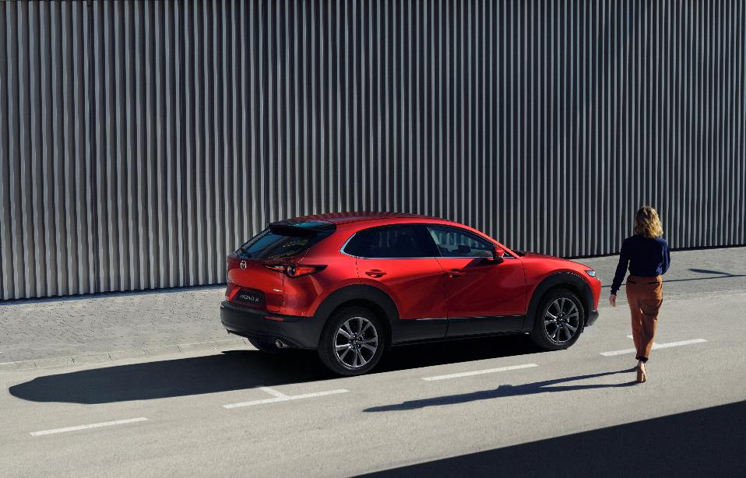On board, the refined interior combines a comfortably snug, highly focused driver's cockpit with an airy, spacious cabin atmosphere, enabling all occupants to enjoy a feeling of connection in a relaxed, comfortable environment. Painstaking attention has been paid to every detail, from choice of materials to fit and finish, creating a genuinely refined, premium quality interior space.

## Exterior Design

The CX-30’s styling was derived from the brushwork used in Japanese calligraphy and developed to integrate the three key factors of the evolved Kodo design theme: *Yohaku*, the beauty of empty space; *Sori*, curves with poise and balance; and *Utsuroi*, the play of light and shade.

*Sori* is embodied in the arc of the shoulder running from the front fender to the rear wheel, giving a sense of speed and vitality. *Utsuroi* may be seen in the body surfaces beneath the shoulder line, which reflect the surroundings in an S shape that changes as the car moves. These expressions of body form finally come together in a single undulation at the rear, where they diffuse.

By eschewing character lines in favour of the movement of surfaces, the Mazda CX-30 achieves styling with both the beauty of a work of art and a powerful sense of dynamism.

Exhibiting a fine balance of refinement and boldness, the front styling of the CX-30 conveys a captivating personality. Mazda's sharp, and profound signature wing seamlessly merges with the sculpted contours of the front bumper, resulting in a composition that evokes a powerful sense of dynamic progress. The radiator grille, meticulously designed with triangular motifs, ensures rich variations that captivate the eye from different angles and play with the interplay of light and shadow.

The rear fenders of the CX-30 boldly project from the tapered rear cabin, forming a distinct visual feature and the tailgate complements this design with a gracefully narrowed arch shape. The harmonious interplay between these elements gives rise to a captivating and dynamically sculpted rear form, reminiscent of the wide and commanding stance typically associated with sports cars.

Combining elegance and functionality, the headlamps and rear combination lamps of the CX-30 are cylindrical in shape and highlighted by an intricate LED arrangement, accentuating their refined appearance. Notably, the 2024 CX-30 showcases LED turn signals with a distinctive light signature. These turn signals show a unique sequence where they start at full power and then gracefully fade in sequential pulses, creating a visually striking and attention-grabbing ‘fade’ effect.

The CX-30 offers a selection of aluminium wheels, allowing you to choose between 18-inch or 16-inch options. The 18-inch wheels, available in Dark Bright Silver or Silver Metallic finish. Their powerfully sculpted spokes harmoniously blend with the cylindrical lug nut surrounds, which feature a machined-finish look. On the other hand, the 16-inch wheels are designed with a spoke pattern that creates an illusion of a larger diameter, while their dark colour finish seamlessly integrates with the tyres, presenting a cohesive and refined aesthetic.

Introducing two new colours, the 2024 CX-30 expands its options to include Zircon Sand and Ceramic. The Ceramic hue presents a silky and translucent appearance while the Zircon Sand exudes a rich and deep expression, emphasising the car's toughness and utility when combined with the black cladding. Alongside these additions, the CX-30’s body colour line-up includes the signature Mazda colours of Soul Red Crystal and Machine Grey with Polymetal Grey, Deep Crystal Blue, Snowflake White, Arctic White, Jet Black, also available, providing a comprehensive range of options to suit a wide range of preferences.

## INTERIOR DESIGN

The design of the Mazda CX-30’s cabin is based on Mazda’s human-centred design philosophy, and traditional Japanese architecture with its use of *Ma,* or empty space. The basic layout combines a snug and condensed cockpit area for the driver, and a clean, airy open space around the front passenger.

The cockpit is symmetrical and firmly centred on the driver, with all three meters in the instrument cluster and the centre display angled towards the driving position for optimum visibility and ease of operation with minimum distraction.

The upper area of the dashboard features a secondary, wing-shaped hood. Running horizontally from the top of the instrument cluster hood into both door trims which are finished with high quality stitching and metallic accents.

A wide centre console groups the shift lever, cup holders and Commander Control in a ‘control area’ close to the driver for convenient, ergonomically considered operation, while the gently curved knee rests and arm rest behind provide support and a cosy atmosphere.

The 2024 CX-30 takes the human-centric philosophy further with enhanced interior ergonomics. Updates include an improved infotainment screen, USB-C ports replacing USB-A, optimised HVAC controls and a darker shade of colour on steering wheel controls for easier visibility.

The Mazda CX-30 comes standard with a black interior colour scheme, accompanied by fabric seats available in Greige or Black. For added personalisation, a further colour scheme is available featuring Rich Brown accents, exuding a chic and mature aesthetic.

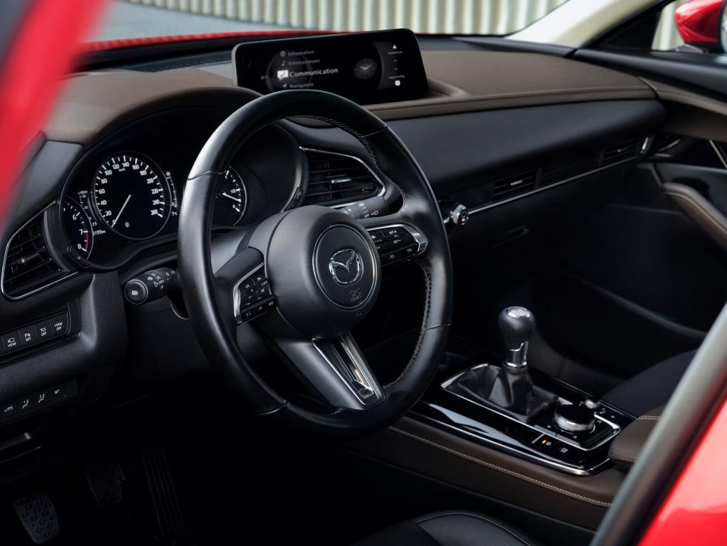The Rich Brown colour scheme offers a choice of Black or Pure White1 leather seats. The Black leather upholstery features perforations that reveal a brown interior liner, adding a touch of sophistication to the premium design. This combination of colours and materials creates a visually striking contrast, enhancing the luxurious and upscale ambiance of the interior.

1 Only available in combination with e-Skyactiv X engine and LHD

1. Compact Exterior - Spacious, Versatile Interior

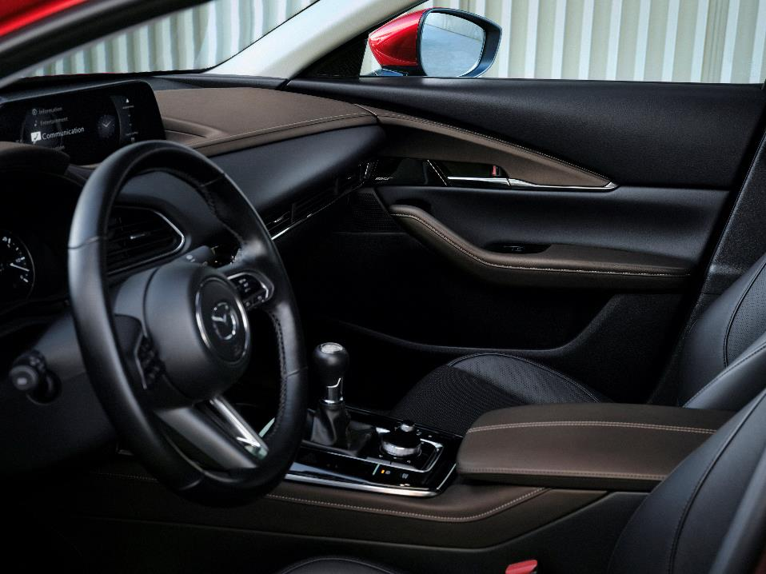Mazda's human-centric approach has led to a thoughtfully designed and versatile interior in the CX-30. Despite its compact exterior, the cabin is well-packaged, supplying a comfortable and relaxed experience for all passengers, even during long drives. Additionally, the generous luggage space effortlessly meets various lifestyle needs, offering practicality and ample capacity.

The driver's environment has been meticulously crafted, incorporating the latest advancements in driving position and Human-Machine Interface (HMI) technology. By applying the most advanced knowledge and technologies, Mazda ensures that the driver's experience is optimised for comfort, control, and seamless interaction with the vehicle's features and functions.

Subtle changes to steering wheel button colours have been implemented to improve legibility and HVAC and 360 view monitoring control locations have been re-arranged for greater ease of use for the 2024 CX-30.

## PACKAGING

The 2024 Mazda CX-30 strikes a balance between compact urban manoeuvrability and a spacious, versatile interior with a large luggage compartment.

The front seats are widely spaced, allowing for a broad centre console with a large centre armrest. Similarly, the rear seat area supplies ample space, enabling comfortable seating postures and the enjoyment of wide rear centre and door armrests. Taller passengers will appreciate the generous knee and headroom made possible by the substantial distance between the front and rear seat hip points, as well as the low rear seat hip-point height.

Despite its appropriate SUV ground clearance, the Mazda CX-30 keeps low seat hip-points and generous door opening heights, ensuring effortless entry and exit of the vehicle. The addition of side seals to the bottom of the rear doors prevents occupants from soiling their clothing when disembarking if the CX-30 is muddy.

The luggage capacity of the Mazda CX-30 is an impressive 430L (VDA), complemented by a wide lift gate opening of 1,030mm and a loading lip height of just 731mm. This setup facilitates easy loading and unloading of heavy or bulky cargo. For added convenience, an optional power-operated tailgate with one-touch opening and closing is available.

The cockpit design reflects a combination of superior ergonomics and Kansei Engineering, which emphasises human feelings. This results in an ideal driving position that accommodates occupants of all sizes. The steering wheel's tilt range of 45mm and telescopic range of 70mm, along with the front seat cushion tilt adjustment, allow for precise customisation of the driving position.

The gear shift lever is positioned high and forward on both automatic and manual transmission versions, enabling quick and seamless transitions from the steering wheel to the shift lever. The Commander Control, cup holder placement, and long centre armrest further enhance operational ergonomics, ease of use, and overall comfort for an enjoyable driving experience.

## IMPROVED HUMAN MACHINE INTERFACE (HMI)

The Active Driving Display, instrument screens and centre display present information in a clear, simple fashion, while the fonts used have been unified to create a pleasing and consistent look. The new 10.25-inch centre display offers simple, straightforward operation via the intuitive Commander Control.

New for the 2024 CX-30 and a first for a Mazda, navigation instructions from Apple CarPlay and Android Auto can also be shown on the Active Driving Display further enhancing safety and convenience for the driver.

In addition, the new 10.25” centre display offers a split-screen view, with the left side of the screen dedicated to navigating the menu, and the right side displaying illustrative options for easy understanding. Furthermore, the display can also show navigation and audio information together, enhancing the functionality of the infotainment system.

Further significant upgrades include a touch-enabled interface for the centre display for Apple CarPlay and Android Auto, supplying a seamless navigation experience for both user interfaces. Wireless versions of both Apple CarPlay and Android Auto are also now available, making it easier than ever to connect your phone to your car. Furthermore, the updated CX-30 now includes a wireless charging pad2, ensuring that your device stays fully charged on long journeys without the need for charging cables.

Mazda's application of the results of human research also extends to the field of Kansei engineering, finely crafting all switches to deliver a consistent feel, regardless of whether they are pushed, pulled, flipped, or turned. For instance, the steering wheel combines the use of both toggle and push-type switches, and the surface of each switch is raised so it is instantly identifiable by touch.

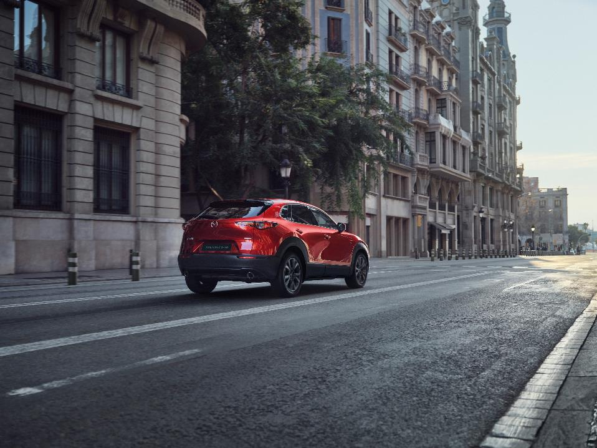Mazda designs its warning alerts to accurately convey important information about any given situation. Audible alerts sound from either the front or rear speakers and displays are carefully worded to make them easily understood by all drivers.

2 Only available as standard on selected models.

## MAZDA CONNECT SYSTEM

Mazda Connect is an advanced in-car infotainment system, incorporating a high-speed screen that enhances user experience with digitalised signal transmissions from the camera and audio system for superior image and sound quality.

The voice recognition system enables safe, effortless operation while driving, with a "Barge-in" function that lets you issue commands even while the system is supplying voice guidance. The "One-shot command" feature enables you to issue a complete command at once, rather than dealing with a chain of commands, for an efficient and streamlined ‘hands-free’ experience.

The improved navigation system now features an online point of interest search function for the 2024 CX-30, making search results more accurate, relevant, and useful. The updates also include enhancements to the off-road mapping functionality that work in conjunction with a 3D gyro sensor that accurately calculates the vehicle's position, even in areas where GPS reception is poor.

In addition to the features mentioned earlier, the 2024 CX-30 boasts further improvements to its navigation system software. One of the major upgrades is the expanded map area, which allows for more essential navigational information to be displayed on one screen than ever before.

With Apple CarPlay and Android Auto, you can also use smartphone navigation applications and use exact positioning information through a mobile operating system. The "One Box Search" function allows you to search for a destination by inputting keywords, making it easy to find your way to your desired location.

**MYMAZDA APP AND CYBER SECURITY**

The MyMazda App offers an array of convenient features to make the ownership experience of the 2024 CX-30 even better. With the app, drivers can easily find their car in a crowded car park using the Vehicle Finder function, remotely lock the doors with the Remote Door Locking feature and receive notifications when any vehicle door is not closed properly.

In addition, the app can be used to search for destinations and send relevant information to the car's navigation system, schedule and manage maintenance appointments, and check vehicle health status. The Roadside Assistance function provides support in case of vehicle malfunction, while the theft-alert function and Security Alert feature help to protect the car from theft and unauthorised access.

To access these features, customers must register for the MyMazda App and enrol with Connected Services. Main drivers can also invite second drivers to the car and choose which functions are available to them. The MyMazda App is available for free from the Apple App Store and the Google Play Store and provides peace of mind and convenience to CX-30 owners 24/7.

The 2024 CX-30 also includes important cyber security updates to protect against IT threats. With these updates, the car is now more secure than ever before, giving drivers peace of mind when it comes to their personal information and the safety of their vehicle.

## Audio Systems

The Mazda CX-30 is available with a choice of two audio systems: the standard 3-way, 8-speaker Mazda Harmonic Acoustics system, and a 12-speaker Bose® system custom-tuned to supply more powerful bass and the enhanced audio quality expected of the Bose® brand.

**MAZDA HARMONIC ACOUSTICS SYSTEM**

Mazda’s commitment to achieving the highest level of audio quality is reflected in the results of their comprehensive studies on how sound travels through a car’s cabin. By strategically placing the 3L bass speakers in the front cowl sides, where low-frequency sound is better reproduced, the CX-30 delivers a more distinct and resonant lower register.

The 2.5cm tweeters and 8cm midrange units have been thoughtfully positioned in the lower corner of the front door window on the left and right side, as well as the upper section of the front and rear door trim, directly transmitting sound towards the occupant’s ears without being distorted by reflected sound.

This meticulous placement enhances the sound’s depth and clarity, making for a more immersive and natural audio experience.

**BOSE PREMIUM SOUND SYSTEM WITH BASSMATCH**

The 12-speaker Bose premium sound system in the Mazda3 is a testament to the long history of collaboration between Mazda and Bose engineers, resulting in a higher level of audio performance through unconventional speaker placements.

The system boasts a BassMatch configuration that combines three bass sources for deeper, more impactful low-frequency reproduction, including two 115mm high-excursion woofers placed in 3 litre low-frequency enclosures near the kick panels, and a 130mm Richbass woofer in an 8-litre custom-engineered enclosure at the rear of the car.

In addition to the BassMatch configuration, the system features two 25mm neodymium tweeters found in each front door, one 80mm Bose Twiddler speaker within the dashboard, four 80mm neodymium mid/high-range units placed in each door, and two 65-mm surround speakers mounted in the C-pillars. Together with the BassMatch units, these speakers deliver a clear, smooth, and balanced sound to all occupants in the cabin.

The system's power is derived from a Bose digital amplifier mounted beneath the front passenger seat, featuring 9 channels of customised equalisation, Bose Centerpoint surround signal processing, and Bose AudioPilot noise-compensation technology. As a result, the Bose system supplies superior audio performance, supplying a listening experience that is both immersive and impactful.



1. *Jinba Ittai*: Effortless, Engaging Driving

With Mazda's goal of achieving the ultimate 'Jinba Ittai' experience - where the vehicle seamlessly becomes an extension of the driver's body, effortlessly controlled without conscious thought - the Mazda CX-30 takes this concept to new heights, offering even greater driving pleasure.

Mazda has introduced Skyactiv-Vehicle Architecture, a revolutionary structural technology designed around the human-centric approach. By using people's inherent balance, this innovative system supplies enhanced onboard comfort and a heightened connection to the driving experience.

The latest Skyactiv engine lineup combines exhilarating performance with improved fuel economy and environmental friendliness. In the 2024 CX-30, these advancements translate into a more comfortable ride, while the coordination of i-Activ AWD and G-Vectoring Control Plus (GVC Plus) ensures a pleasant, comfortable, and confidence-inspiring driving experience.

Moreover, attention has been given to the cabin's quietness, meticulously fine-tuning its NVH (noise, vibration, and harshness) performance based on extensive studies of human sensory characteristics.

## Powertrain line-up

The CX-30 powertrain line-up showcases the latest Mazda Euro 6d e-Skyactiv petrol engines, including the revolutionary e-Skyactiv X.

The clean and efficient e-Skyactiv G and e-Skyactiv X engines are available with a choice of front or all-wheel drive, and six-speed Skyactiv-MT manual or six-speed Skyactiv-Drive automatic transmissions.

|  |  |  |  |
| --- | --- | --- | --- |
| Engine | e-Skyactiv G 2.0 122 PS | e-Skyactiv G 2.0 150 PS | e-Skyactiv X 2.0 186 PS |
| Transmission | 6MT / 6AT | 6MT / 6AT | 6MT / 6AT |
| Powertrain | FWD / AWD | FWD / AWD | FWD / AWD |
| Mazda M Hybrid | Standard | Standard | Standard |
| i-Stop | Standard | Standard | Standard |
| Cylinder Deactivation | Standard | Standard | - |
| Emission rating | Euro 6d | Euro 6d | Euro 6d |

In keeping with the latest Euro 6d emissions regulations, all engines used in the Mazda CX-30 are homologated according to the requirements of the WLTP/RDE test cycle

## e-Skyactiv X Engine

Incorporating Mazda M Hybrid technology as a standard, e-Skyactiv X delivers 186 PS (137 kW) at 6,000 rpm and maximum torque of 240 Nm at 4,000 rpm. It combines an average fuel consumption of 6.6-5.6 l/100 km with CO2 emissions of 149-127 g/km WLTP3.

When accelerating from low revs in partial load driving scenarios like accelerating from 30-80 in 3rd gear, the engine's broad torque output supplies strong pulling power throughout the rev range, delivering impressive acceleration under full engine load from above 2000 rpm.

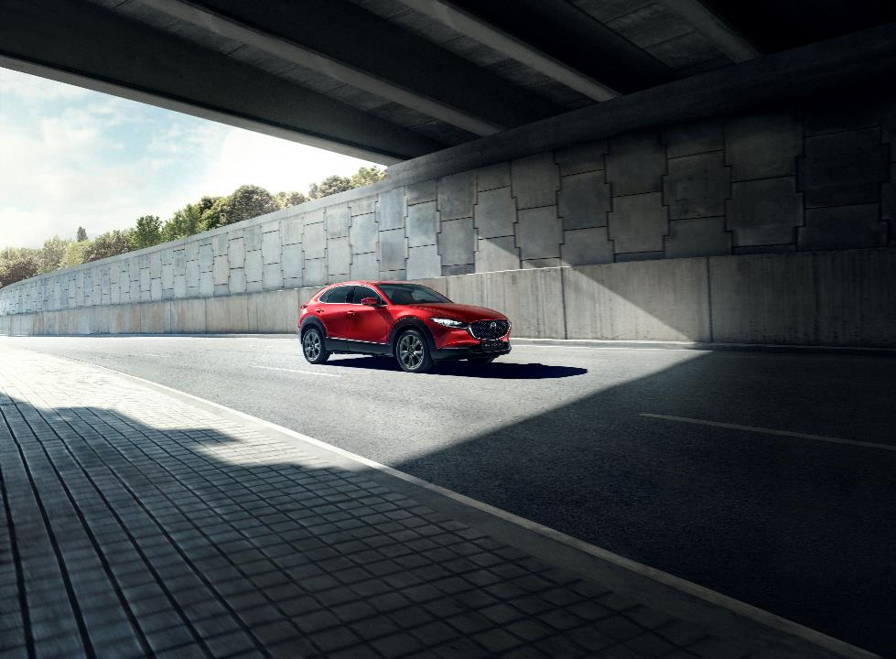The e-Skyactiv X engine offers a choice between the six-speed Skyactiv-MT manual or six-speed Skyactiv-Drive automatic transmissions, each supplying a smooth and efficient ride.

3 Vehicles are homologated following the type approval procedure WLTP (Regulation (EU) 1151 / 2017; Regulation (EU) 2007/715).

## e-Skyactiv G 2.0 Engine

Mazda’s latest e-Skyactiv G 2.0 engine is available in two versions. One develops 122 PS at 6,000 rpm and maximum torque of 213 Nm at 4,000 rpm, the other 150 PS at 6,000 rpm with both producing maximum torque of 213 Nm at 4,000 rpm. Both engines combine an average fuel consumption of 6.9-5.9 l/100 km with CO2 emissions of 156-134 g/km4.

These clean and efficient engines come with a choice of the six-speed Skyactiv-MT manual or six-speed Skyactiv-Drive automatic transmissions, supplying a smooth and responsive driving experience. The advanced cylinder deactivation system seamlessly switches between two-cylinder and four-cylinder operation, based on the driving conditions. In light-load situations, such as when cruising at a constant speed, the system automatically shuts down cylinders one and four, reducing pumping loss and mechanical resistance. This results in improved fuel savings without any noticeable change felt by the driver.

With precise control over airflow intake volume, fuel injection rates, and ignition timing, the e-Skyactiv G engine supplies a seamless and effortless driving experience. The driver can enjoy a comfortable and fuel-efficient ride without compromising on performance.

**Mazda M Hybrid system**

All CX-30 models powered by the e-Skyactiv G and e-Skyactiv X engines come equipped with a 24V mild hybrid system as standard, which helps to minimise fuel consumption and improve fuel economy. This innovative system recycles energy that is usually wasted during deceleration and uses it to power an electric motor that aids the engine. Additionally, the Mazda M Hybrid system supports extended engine off periods such as when waiting at traffic lights for even greater fuel savings.

The belt-driven integrated starter generator (ISG) is the heart of the system, converting the kinetic energy recovered during deceleration into electric power and storing it in a lithium-ion battery with a capacity of 600kJ. A DC-DC converter is then used to convert the power to the appropriate voltage and supply it to the car's electrical equipment.

The placement of the lithium-ion battery between the wheels serves multiple purposes. Firstly, it minimises its impact on interior space, ensuring maximum utilisation of the cabin. Additionally, this strategic positioning helps optimise weight distribution, contributing to improved overall balance and safety in case of a collision.

4 Vehicles are homologated following the type approval procedure WLTP (Regulation (EU) 1151 / 2017; Regulation (EU) 2007/715).

With the innovative brake-by-wire technology of the Mazda M Hybrid system, the blending of electric and friction brake forces is seamlessly and dynamically executed. This intelligent integration maximises both stopping power and energy recuperation efficiency. As a result, the system not only delivers short braking distances and supports high levels of vehicle stability, but it also transforms electric brake force into usable energy, leading to significant reductions in CO2 emissions.

To ensure safety and reliability, the electronically controlled brake-by-wire system is designed to automatically revert to entirely mechanical friction braking in case of an electrical system failure. This fail-safe feature guarantees that braking functionality stays intact even under challenging circumstances.

Not only does the Mazda M Hybrid system enhance the car's environmental performance, but it also ensures better drivability. Transitions during starting, accelerating, or coming to a stop are smooth and natural, and the hybrid system can substitute engine torque for electric motor torque, resulting in the same acceleration while using less fuel. This not only reduces fuel consumption and CO2 emissions but also supplies a more refined and enjoyable driving experience.

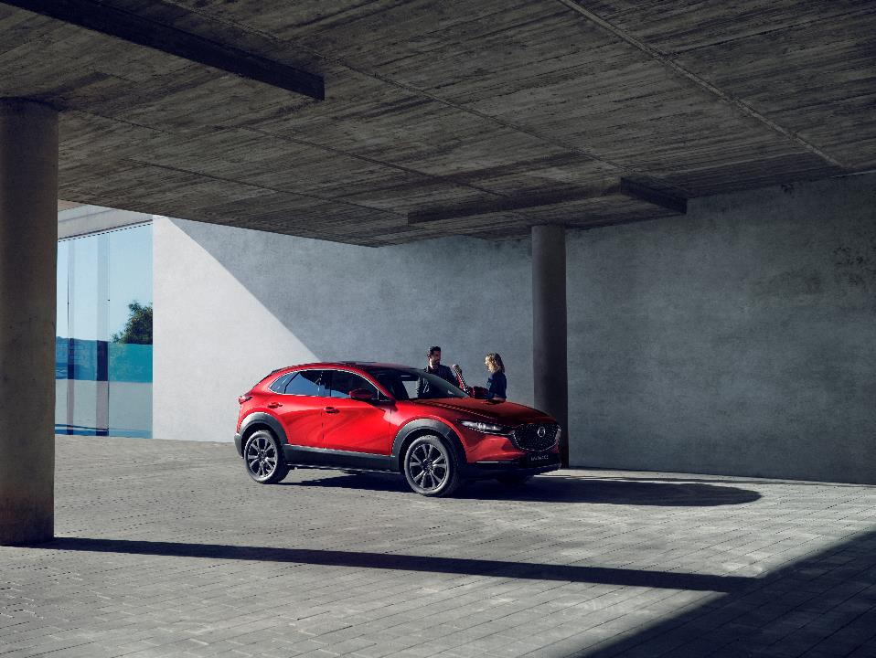

1. Skyactiv-Vehicle Dynamics: New-generation Control Technologies

## AERODYNAMICS

The Mazda CX-30 excels in both aerodynamic efficiency and aesthetic appeal, seamlessly blending outstanding airflow dynamics with the Kodo - Soul of Motion design language.

The carefully crafted shaping of the signature wing plays a crucial role in enhancing aerodynamic efficiency. The forefront of the wing guides oncoming air along the surface of the hood, effectively minimising airflow turbulence without compromising the vehicle's beauty and dynamism.

To address areas that are particularly susceptible to turbulence, such as the tyres and the back of the vehicle, small fin-shaped structures are strategically placed. These structures, found on the lower edge of the front bumper, side garnishes, and rear bumper, intelligently direct air flow around these areas, ensuring best aerodynamic performance while preserving the SUV silhouette.

Furthermore, the Mazda CX-30 is equipped with two air curtains on each side of the car body. These air curtains utilise ducts found on both the lower edge of the bumpers and the front tyre deflectors. By directing oncoming air to create a steady current along the outer surface of the tyres, they effectively reduce turbulence, further enhancing the vehicle's overall aerodynamic capabilities.

**i-Activ AWD**

i-Activ AWD is an advanced all-wheel-drive system that always supplies exceptional grip and stability, ensuring smooth acceleration, braking, and cornering in all conditions. The system constantly checks driving conditions and adjusts the balance between front and rear tyre grip to support best vehicle stability.

Using a range of sensors, i-Activ AWD calculates the amount of torque needed to prevent slippage of the front wheels, and continuously adjusts the torque distribution to the rear wheels to ensure maximum stability. Additionally, i-Activ AWD works seamlessly with G-Vectoring Control Plus (GVC Plus) to distribute torque according to the vehicle's driving conditions, optimising fuel economy by minimising mechanical loss.

## G-Vectoring Control Plus (GVC Plus)

G-Vectoring Control Plus (GVC Plus) is an advanced control systems that enhances the 2024 CX-30's handling and driving experience. GVC was the first system in the world to vary engine torque to optimise the vertical load on each wheel, providing more precise handling and improved comfort. GVC Plus builds on this by using the brakes to add direct yaw moment control, further enhancing handling stability and achieving a unified feel of dynamic performance.

As the driver steers out of a corner, GVC Plus applies a light braking force to the outer wheels, supplying a stabilising moment that helps to restore the vehicle to a straight line. This results in consistently smooth transitions between yaw, roll and pitch, even under high cornering forces. Not only does GVC Plus increase handling stability, but it also increases comfort as smoother G-force transitions reduce the amount of body sway experienced by the driver and passengers.

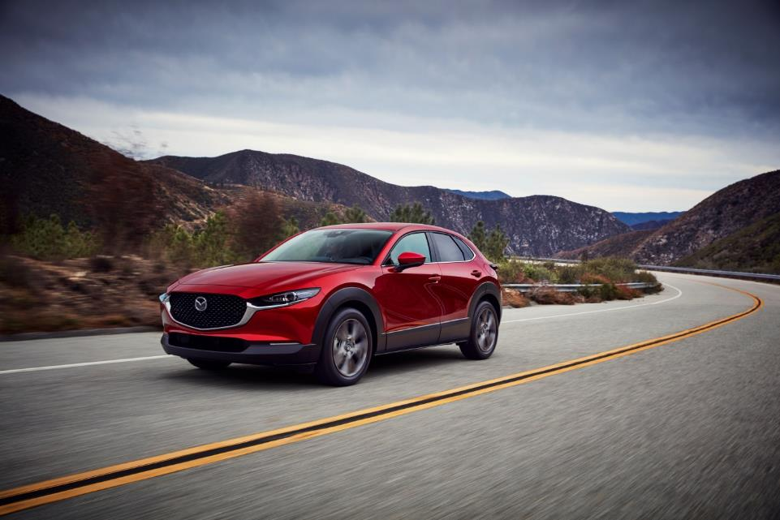

1. Skyactiv-Vehicle Architecture: New-generation Structural Technologies

Mazda's next-generation Skyactiv-Vehicle Architecture embodies a human-centric development approach. This approach recognises and harnesses the inherent balance of vehicle occupants, allowing them to keep their equilibrium while the car is in motion.

Unlike a conventional focus on optimising individual components like seats, body, chassis, and tyres, Mazda has taken an integrated approach by prioritising the coordination of the entire vehicle. This comprehensive perspective involves re-allocating functions and optimising their interplay to create an architecture that seamlessly works as a unified and coordinated whole.

The result is a driving experience that not only emphasises comfort and safety but also establishes a deep connection between the driver and the vehicle, enabling an intuitive and harmonious interaction.

**SEATS**

The front seats of the CX-30 have been designed to supply exceptional support and support the natural alignment of the spine. The seat design focuses on supporting the pelvis and preserving the S-shaped curve of the spine, promoting a comfortable sitting posture.

The seat cushion and lower seatback work together to supply the necessary support to keep the pelvis in an upright position. This positioning helps keep proper alignment and reduces strain on the lower back. Additionally, the upper seatback is shaped to bolster the gravity centre of the rib cage, further contributing to stability and comfort.

Importantly, the shaping and springing of the front seat cushion and seatback have been carefully engineered to accommodate a wide range of body types. This design allows occupants to effortlessly adjust their pelvis and spine to find their body's centre of gravity, without requiring conscious effort. It also enables occupants to naturally stabilise their head in response to the road surface, enhancing overall comfort and reducing fatigue.

By promoting a balanced and supported posture that requires minimal exertion, the CX-30's front seats ensure reduced fatigue and enhanced comfort, even during long drives. Occupants can enjoy a pleasurable and relaxed experience behind the wheel, allowing them to focus on the journey ahead.

**BODYSHELL, SUSPENSION AND BRAKES**

The CX-30's Skyactiv-Vehicle Architecture has been designed to achieve a perfect balance of ride comfort and handling stability. The multi-directional ring structures and damping structures in the body increase rigidity while reducing lag in the transmission of energy, helping to maximise the function of the dampers and tyres. The suspension system has been designed to smooth the transmission of force to the sprung mass over time, ensuring rapid, lag-free transmission of inputs.

The brake design has also been optimised for performance and ease of use. It has been designed to make it easy for the driver to sense when the brakes start engaging, allowing them to easily adjust the rate of deceleration. The brake design maintains constant clearance between the brake pads and rotors, regardless of whether the brakes are lightly or firmly applied, reducing rolling resistance and improving brake pedal feel.

Additionally, the brake pedal components have been designed in a way to reduce driver fatigue and improve control in the leg and foot when creating a braking motion.

**NVH PERFORMANCE**

The CX-30 development team put significant effort into reducing noise and vibrations in the cabin, using research studies and innovative design solutions. They implemented a "two-wall" structure that creates an air pocket between the floor carpeting and body panel, which improves the sound insulation quality. A seal inside the parting lines between the roof panel and liftgate/rear window also reduces noise caused by wind.

Sound-absorbing materials were used for the headliner and floor mats, which quickly suppress high-frequency noise when the road surface changes. Tyres with optimised vertical spring action help absorb vibrations and reduce the transmission of road surface changes to the cabin. The car's high rigidity also helps to minimise vibrations and the perceived noise level.

Finally, the engine control system and mounts were optimised to suppress unpleasant vibrations and provide a smooth and clearly audible restart. The belt driven ISG used in both engines enables the hybrid system's motor to move the pistons to a position where they will start again smoothly, regardless of the operating environment. The result is a high-quality quietness that is pleasing to all cabin occupants, even at highway speeds.

1. Advanced SAFETY Technology

Mazda's i-Activsense suite of innovative safety technologies empowers the driver to stay vigilant and avoid potential hazards with ease. Notably, the 2024 CX-30 now includes four newly improved active safety features that work in tandem to ensure maximum safety – the addition of Distracted Driver Alert, improved night-time Autonomous Emergency Braking (AEB), enhanced accuracy of the Intelligent Speed Assist (ISA) system and speed improvements to the Cruising & Traffic Support (CTS) system.

## Active Safety: i-Activsense

|  |  |
| --- | --- |
| **Accident prevention and damage mitigation** | |
| Smart Brake Support (SBS) | Standard |
| Smart Brake Support [Rear] (SBS-R) | Optional |
| Smart Brake Support [Rear Crossing] (SBS-RC) | Optional |
| **Support for potential hazard awareness** | |
| Adaptive LED Headlights (ALH) | Optional |
| High Beam Control (HBC) | Standard |
| 360° View Monitor | Optional |
| Front Cross Traffic Alert (FCTA) | Optional |
| Blind Spot Monitoring (BSM) | Standard |
| Rear Cross Traffic Alert (RCTA) | Standard |
| Lane Departure Warning System (LDWS) | Standard |
| Lane-keep Assist System (LAS) | Standard |
| **Driver support** | |
| Traffic Sign Recognition system (TSR) | Standard |
| Intelligent Speed Assistance (ISA) | Standard |
| Driver Attention Alert (DAA) | Standard |
| Driver Monitoring | Optional |
| Mazda Radar Cruise Control (MRCC) | Standard |
| Cruising & Traffic Support (CTS) | Optional |

Ein Bild, das Straße, Gebäude, draußen, rot enthält.

#### DRIVER MONITORING WITH DISTRACTED DRIVER ALERT

The Distracted Driver Alert is designed to detect if the driver is not paying attention to the road. The system uses an infrared camera and LED sensors to watch the driver's facial expression and eye movements.

If the system detects that the driver is not looking at the road for an extended period, it will issue a visual and audible alert on the instrument cluster, to remind the driver to pay attention. The system will also detect if the driver is drowsy or falling asleep, and it will issue a similar alert in this case.

This safety feature is significant because distracted driving is a leading cause of accidents on the road. By alerting drivers when they are not paying attention, the driver monitoring system can help prevent accidents and improve the safety of the driver, passengers, and other road users.

### NIGHT-TIME AUTONOMOUS EMERGENCY BRAKING

Newley added to the 2024 CX-30, Mazda's night-time Autonomous Emergency Braking (AEB) system is a safety feature that is designed to help drivers avoid collisions in low-light conditions by using a combination of radar and camera sensors to detect obstacles in the road ahead, even in the dark.

Reacting quicker than previously, if the system detects a potential collision with a pedestrian, bicyclist, or other obstacle, it first alerts the driver with audible and visual warnings. If the driver does not respond, the system can automatically apply the brakes to prevent or reduce the severity of the collision.

The night-time AEB system uses a special camera that is sensitive to both visible and infrared light, allowing it to detect obstacles even when there is little ambient light. This camera works in conjunction with the car's adaptive headlights, which can adjust their direction and intensity based on the car's speed and steering angle to supply the best illumination of the road ahead.

By using a combination of sensors and advanced algorithms, the night-time AEB system can detect and respond to potential hazards on the road in real-time, helping to keep drivers, passengers, and other road users safe even in challenging driving conditions.

### Intelligent Speed Assist

Mazda's Intelligent Speed Assist (ISA) safety system has been updated for the 2024 CX-30 and is designed to help drivers keep a safe and legal speed while driving. The system uses a forward-facing camera to detect speed limit signs and compares them to the vehicle's current speed. If the system finds that the vehicle is exceeding the speed limit, it will supply an audible and visual warning to the driver to slow down. The system also allows the driver to set a maximum speed limit that the vehicle will not exceed, supplying an added layer of safety.

Improvements in data usage from the navigation system and road sign recognition have enhanced system accuracy to even greater levels for the 2024 CX-30.

#### CRUISING AND TRAFFIC SUPPORT (CTS)

Mazda's Cruising & Traffic Support (CTS) system is an advanced safety feature that helps drivers to stay safe and comfortable during long journeys or heavy traffic situations. It is designed to supply support for acceleration, braking and steering, especially in congested driving conditions.

The system uses radar and camera technology to detect the position of other vehicles on the road and can adjust the speed of the car accordingly to keep a safe distance from other vehicles. Additionally, for the 2024 CX-30, CTS can now supply steering assistance (lane centreing) up to a speed of 150km/h to help keep the vehicle centred within its lane, making driving in heavy traffic less stressful.

CTS also includes Mazda's Adaptive Cruise Control (ACC) with Stop & Go5, which can automatically adjust the car's speed based on the speed of the car in front of it. If the car in front comes to a complete stop, ACC can bring the CX-30 to a complete stop as well and will resume driving once the car in front moves and the driver gives a prompt.

## Passive safety

#### LIGHTWEIGHT, HIGH-RIGIDITY BODY

The Mazda CX-30’s bodyshell is crafted with 30% of it using ultra-high tensile steel rated 980MPa or higher. It stands out as the first car worldwide to adopt cold-stamped vehicle body parts made of 1,310 MPa-grade high-tensile steel, resulting in an impressively light yet strong structure. This state-of-the-art design provides the CX-30 with a robust architecture capable of withstanding impact, while the frame structure effectively absorbs impact energy to minimise the risk of occupant injury.

#### FRONT, SIDE AND REAR IMPACT PROTECTION MEASURES

To further enhance safety, the CX-30 features an extended bumper beam and a perimeter beam that work together to reduce the force of frontal impact in an offset collision. The perimeter beam guides energy to the load paths, which then send impact energy towards the rear of the vehicle. Furthermore, a bendable front frame structure takes the brunt of the impact and gradually absorbs energy, further improving safety for occupants.

In case of a side impact, the CX-30's design disperses the energy in multiple directions to the front and rear of the vehicle, minimising cabin deformation. Additionally, the side frames of the CX-30 deform in an accordion-like pattern in case of a rear collision, adding an extra layer of protection for passengers.

**SEATBELTS, ANTI-WHIPLASH FRONT SEATS AND SRS AIRBAGS**

The 2024 CX-30's safety features also include a thoughtful approach to seatbelt design. The lower mounts for the front seatbelts are attached to the seat itself, which minimises slack and enables quicker restraint in case of a collision. In addition, the seatbelt's pretensioner and load limiters work in tandem to instantly tighten and later loosen the seatbelt in a controlled manner to further protect occupants.

The seat structure is designed with safety in mind and minimises movement of the occupant's head, chest, and hips during a collision, reducing the likelihood of neck injury. The seat's side frames play a crucial role in absorbing energy and minimising the amount of reaction needed to return the seatback to its original position, thereby reducing the risk of the seat pushing the occupant's head forward and causing further harm.

In addition to the standard front, curtain, and side airbags, the CX-30 includes a driver's seat knee airbag as standard equipment in all markets.

The driver's seat knee airbag further enhances occupant protection by supplying an added cushioning barrier in case of a collision. This airbag is strategically positioned to help reduce the risk of injury to the driver's knees and lower extremities, adding an extra layer of safety to the overall occupant protection system.

## PEDESTRIAN PROTECTION

Mazda takes pedestrian safety seriously during design and development, and this is no different for the 2024 CX-30. The front hood of the car features a pattern of parallel columns that are positioned close to the surface, which minimises the amount of deformation upon impact, allowing for faster energy absorption. This design feature aims to protect the pedestrian's head and reduce the severity of injuries in case of an accident.

In addition, the front bumper of the CX-30 is specifically designed to control how force is applied upon contact with a pedestrian's legs. By reducing the impact on the knee area, the bumper structure helps to mitigate injury and improve safety for pedestrians. These design elements demonstrate Mazda's commitment to safety for all road users.

Ein Bild, das Straße, draußen, Himmel, Berg enthält.

1. Technical Specifications

|  |  |  |
| --- | --- | --- |
| **Body type** | | Monocoque |
| Doors | | 4 + liftgate |
| Seating capacity | | 5 |
| **External** | | |
| Overall length (with licence plate holder) | mm | 4,395 |
| Overall width (with wheel arch moulding) | mm | 1,795 |
| Overall width (mirror to mirror) | mm | 2,040 |
| Overall height (unladen, without shark fin antenna) | mm | 1,540 |
| Wheelbase | mm | 2,655 |
| Overhang front (with licence plate holder) | mm | 915 |
| Overhang rear | mm | 825 |
| Track width front | mm | 1,565 |
| Tread width rear | mm | 1,565 |
| Ground clearance between axles (laden, w. 75kg driver) | mm | 175 |
| **Interior** | | |
| Front headroom (without sunroof) | mm | 967 |
| Rear headroom | mm | 973 |
| Front shoulder room | mm | 1,412 |
| Rear shoulder room | mm | 1,361 |
| Front hip room | mm | 1,388 |
| Rear hip room | mm | 1,352 |
| Rear legroom | mm | 921 |
| **Boot** | | |
| Volume with rear seats up VDA (with under floor storage) | l | 430 (422 with Bose) |
| Volume to roof, rear seats folded down VDA (with under floor storage) | l | 1,406 (1,398 with Bose) |
| Height, from floor to tonneau cover | mm | 570 (525 with Bose) |
| Load floor length to 2nd row | mm | 809 |
| Loading sill height from ground | mm | 533 |
| Liftgate opening width | mm | 1,030 |

#### ENGINE LINE-UP

|  | | e-SKYACTIV G 2.0  (122 PS) | | | | e-SKYACTIV G 2.0 (150 PS) | | | | e-SKYACTIV X  (186 PS) | | | |
| --- | --- | --- | --- | --- | --- | --- | --- | --- | --- | --- | --- | --- | --- |
| Drivetrain | | FWD | | AWD | | FWD | | AWD | | FWD | | AWD | |
| Transmission | | 6MT | 6AT | 6MT | 6AT | 6MT | 6AT | 6MT | 6AT | 6MT | 6AT | 6MT | 6AT |
| Engine type | | I4 DOHC 16 valves | | | | I4 DOHC 16 valves | | | | I4 DOHC 16 valves | | | |
| Displacement | cm3 | 1,998 | | | | 1998 | | | | 1,998 | | | |
| Bore x stroke | | 83.5 x 91.2 | | | | 83.5 x 91.2 | | | | 83.5 x 91.2 | | | |
| Fuel injection type | | Direct injection | | | | Direct injection | | | | Direct injection | | | |
| Compression ratio | | 13.0:1 | | | | 13.0:1 | | | | 15.0:1 | | | |
| Emission control system | | Three-way catalyst | | | | Three-way catalyst | | | | Three-way catalyst + GPF | | | |
| Max. power | kW (PS)/ rpm | 90 (122) / 6,000 | | | | 110 (150) / 6,000 | | | | 137 (186) / 6,000 | | | |
| Max. torque | Nm/ rpm | 213 / 4,000 | | | | 213 / 4,000 | | | | 240 / 4,000 | | | |
| Recommended fuel type | | 95 RON | | | | 95 RON | | | | 95 RON | | | |
| Fuel tank capacity | l | 51 | | 48 | | 51 | | 48 | | 51 | | 48 | |

#### MAZDA M HYBRID SYSTEM

|  | | e-SKYACTIV G 2.0  (122 PS) | e-SKYACTIV G 2.0 (150 PS) | e-SKYACTIV X  (186 PS) |
| --- | --- | --- | --- | --- |
| Voltage | | 24 Volt Mild Hybrid | | |
| Hybrid type | | Belt-driven integrated starter generator (B-ISG) | | |
| Battery information | kJ | 600 - lithium-ion battery | | |
| DC/DC converter | kW | 1.7 (max 120A) | | |

#### MANUAL TRANSMISSION: SKYACTIV-MT

|  |  |  |  |  |  |  |
| --- | --- | --- | --- | --- | --- | --- |
|  | e-SKYACTIV G 2.0  (122 PS) | | e-SKYACTIV G 2.0 (150 PS) | | e-SKYACTIV X  (186 PS) | |
| Transmission | 6MT | | 6MT | | 6MT | |
| Drivetrain | FWD | AWD | FWD | AWD | FWD | AWD |
| **Gear ratios** | | | | | | |
| 1st | 3.700 | 3.700 | 3.700 | 3.700 | 3.272 | 3.272 |
| 2nd | 1.947 | 1.947 | 1.947 | 1.947 | 1.947 | 1.947 |
| 3rd | 1.300 | 1.300 | 1.300 | 1.300 | 1.379 | 1.379 |
| 4th | 1.029 | 1.029 | 1.029 | 1.029 | 1.090 | 1.090 |
| 5th | 0.837 | 0.837 | 0.837 | 0.837 | 0.880 | 0.880 |
| 6th | 0.680 | 0.680 | 0.680 | 0.680 | 0.645 | 0.645 |
| Reverse | 3.724 | 3.724 | 3.724 | 3.724 | 3.385 | 3.385 |
| Final drive ratio | 3.850 | 4.105 | 3.850 | 4.105 | 4.105 | 4.105 |

#### AUTOMATIC TRANSMISSION: SKYACTIV-DRIVE

|  |  |  |  |  |  |  |
| --- | --- | --- | --- | --- | --- | --- |
|  | e-SKYACTIV G 2.0  (122 PS) | | e-SKYACTIV G 2.0 (150 PS) | | e-SKYACTIV X  (186 PS) | |
| Transmission | 6AT | | 6AT | | 6AT | |
| Drivetrain | FWD | AWD | FWD | AWD | FWD | AWD |
| **Gear ratios** | | | | | | |
| 1st | 3.552 | 3.552 | 3.552 | 3.552 | 3.552 | 3.552 |
| 2nd | 2.022 | 2.022 | 2.022 | 2.022 | 2.022 | 2.022 |
| 3rd | 1.347 | 1.347 | 1.347 | 1.347 | 1.347 | 1.347 |
| 4th | 1.000 | 1.000 | 1.000 | 1.000 | 1.000 | 1.000 |
| 5th | 0.745 | 0.745 | 0.745 | 0.745 | 0.745 | 0.745 |
| 6th | 0.599 | 0.599 | 0.599 | 0.599 | 0.599 | 0.599 |
| Reverse | 3.052 | 3.052 | 3.052 | 3.052 | 3.052 | 3.052 |
| Final drive ratio | 4.095 | 4.367 | 4.095 | 4.367 | 4.367 | 4.669 |

#### SUSPENSION AND WHEELS

|  |  |  |  |
| --- | --- | --- | --- |
|  | e-SKYACTIV G 2.0  (122 PS) | e-SKYACTIV G 2.0 (150 PS) | e-SKYACTIV X  (186 PS) |
| **Suspension** | | | |
| Front suspension | MacPherson strut | | |
| Rear suspension | Torsion Beam | | |
| **Wheel & Tyres** | | | |
| Wheel size | 16x6-1/2J  18X7J | | |
| Tyre size | 215/65R16  215/55R18 | | |

#### STEERING AND BRAKES

|  |  |  |  |  |
| --- | --- | --- | --- | --- |
|  | | e-SKYACTIV G 2.0  (122 PS) | e-SKYACTIV G 2.0 (150 PS) | e-SKYACTIV X  (186 PS) |
| **Steering** | | | | |
| Steering type |  | Rack and pinion | | |
| Power assist type |  | Electric Power Assisted Steering (EPAS) | | |
| Turning circle radius  (kerb to kerb) | m | 5.3 | | |
| Turning circle diameter  (wall to wall) | m | 11.37 | | |
| **Brakes** | | | | |
| Type front |  | Ventilated discs | | |
| Type rear |  | Solid discs | | |
| Diameter front | mm | 295 | | |
| Diameter rear | mm | 265 | | |

#### WEIGHT AND PAYLOAD

|  |  |  |  |  |  |  |  |  |  |  |  |  |  |
| --- | --- | --- | --- | --- | --- | --- | --- | --- | --- | --- | --- | --- | --- |
|  | | e-SKYACTIV G 2.0  (122 PS) | | | | e-SKYACTIV G 2.0 (150 PS) | | | | e-SKYACTIV X  (186 PS) | | | |
| Transmission | | 6MT | | 6AT | | 6MT | | 6AT | | 6MT | | 6AT | |
| Drivetrain | | FWD | AWD | FWD | AWD | FWD | AWD | FWD | AWD | FWD | AWD | FWD | AWD |
| Min. kerb weight | kg | 1,351 | 1,437 | 1,378 | 1,463 | 1,351 | 1,437 | 1,378 | 1,463 | 1,404 | 1,492 | 1,427 | 1,510 |
| Max. Permissible weight (GVW) | kg | 1,927 | 1,995 | 1,957 | 2,021 | 1,927 | 1,995 | 1,957 | 2,021 | 1,965 | 2,042 | 1,965 | 2,070 |
| Permissible front axle weight | kg | 1,019 | 1,059 | 1,052 | 1,092 | 1,019 | 1,060 | 1,059 | 1,092 | 1,092 | 1,112 | 1,120 | 1,141 |
| Permissible rear axle weight | kg | 983 | 1,011 | 980 | 1,004 | 983 | 1,011 | 980 | 1,004 | 960 | 1,005 | 958 | 1,003 |
| Permissible tow weight, trailer without brakes | kg | 600 | 600 | 600 | 600 | 600 | 600 | 600 | 600 | 600 | 600 | 600 | 600 |
| Permissible tow weight, trailer with brakes  (8%/12% gradient) | kg | 1,300 | 1,300 | 1,300 | 1,300 | 1,300 | 1,300 | 1,300 | 1,300 | 1,300 | 1,300 | 1,300 | 1,300 |
| Max. roof load capacity | kg | 75 | 75 | 75 | 75 | 75 | 75 | 75 | 75 | 75 | 75 | 75 | 75 |

#### PERFORMANCE

|  | | e-SKYACTIV G 2.0  (122 PS) | | | | e-SKYACTIV G 2.0 (150 PS) | | | | e-SKYACTIV X  (186 PS) | | | |
| --- | --- | --- | --- | --- | --- | --- | --- | --- | --- | --- | --- | --- | --- |
| Transmission | | 6MT | | 6AT | | 6MT | | 6AT | | 6MT | | 6AT | |
| Powertrain | | FWD | AWD | FWD | AWD | FWD | AWD | FWD | AWD | FWD | AWD | FWD | AWD |
| **Performance** | | | | | | | | | | | | | |
| Top speed 6 | km/h | 186 | 182 | 186 | 182 | 198 | 197 | 194 | 193 | 204 | 204 | 204 | 204 |
| Acceleration  (0-100km/h) [1] | secs. | 10.6 | 11.1 | 11.2 | 11.7 | 8.8 | 9.1 | 10.0 | 10.4 | 8.3 | 8.8 | 8.7 | 9.0 |
| **WLTP fuel consumption**[2] | | | | | | | | | | | | | |
| Combined | l/100 km | 5.9 | 6.4 | 6.4 | 6.9 | 5.9 | 6.4 | 6.4 | 6.9 | 5.7 | 6.1 | 6.1 | 6.6 |
| Extra-High | l/100 km | 6.3 | 6.7 | 6.7 | 7.2 | 6.3 | 6.7 | 6.7 | 7.2 | 6.1 | 6.5 | 6.6 | 7.0 |
| High | l/100 km | 5.1 | 5.5 | 5.4 | 5.9 | 5.1 | 5.5 | 5.4 | 5.9 | 4.9 | 5.3 | 5.2 | 5.7 |
| Medium | l/100 km | 5.5 | 6.2 | 6.1 | 6.6 | 5.5 | 6.2 | 6.1 | 6.6 | 5.4 | 5.9 | 5.8 | 6.3 |
| Low | l/100 km | 7.3 | 8.1 | 8.5 | 8.9 | 7.3 | 8.1 | 8.5 | 8.9 | 6.7 | 7.3 | 7.5 | 7.9 |
| CO2 emissions (combined) | g/km | 134 | 144 | 144 | 156 | 134 | 144 | 144 | 156 | 128 | 137 | 138 | 149 |
| Emissions rating | | Euro 6d | | | | | | | | | | | |

#DriveTogether

#Mazda

#CX30

For more information, please visit the Mazda Press Portal  
www.mazda-press.com

1. Under Mazda test conditions.
2. Vehicles are homologated following the type approval procedure WLTP (Regulation (EU) 1151 / 2017; Regulation (EU) 2007/715).